Team Name: Derpsters

Team Members: Musamim Mubtakir & David Real

Project Documentation

Project Information and Details:

* The problem we are solving in this program are cyphering.
* The program interacts with the user in the sense that it asks the user for the message and the key to encrypt or decrypt.
* We had a lot of trouble writing the code for the program, especially the formulas. Debugging took the longest.
* Discrete structures is implemented in the program through the labs and the in-class assignments, where we learned about vigenere cyphering.

Flowchart:

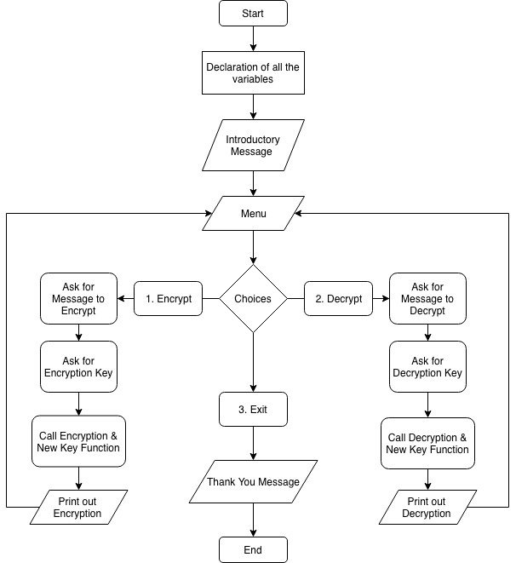

Pseudocode:

Function for Encryption

* Pass in message and key
* Return Encrypted message

Function for Decryption

* Pass in message and key
* Return Decrypted Message

Function for New Key Generator

* Pass in key
* Returns the New key

Main Function

* Variables Declared
* Introductory Message
* Do while loop
* Menu with 3 options consisting of Encrypt, Decrypt and Exit
* Choice inputted
* While loop for making sure choices 1, 2 and 3 and inputted
* If statement for choice 1
  + Ask user to enter message
  + Ask user for a key
  + Call function Encrypt
  + Call function Key
  + Output the Original Message, Key, New Key, and Encrypted Message.
* Else if statement for choice 2
  + Ask user to enter message
  + Ask user for a key
  + Call function Decrypt
  + Call function Key
  + Output the Original Message, Key, New Key, and Decrypted Message.
* Else Statement for Choice 3
  + Print out Thank you message